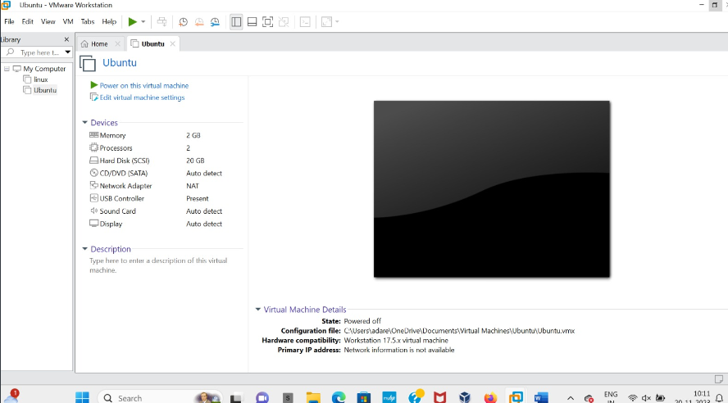

Experiment
–

16

Cloning of a Virtual Machine and Testing the Cloned VM Using VMware Workstation

Aim

To create a clone of a virtual machine using VMware Workstation and test the cloned virtual
machine by starting and verifying its operation.

Procedure

1
. Open VMware Workstation on the Windows host operating system.

2
. Select the Ubuntu virtual machine that needs to be cloned.

3
. Ensure that the virtual machine is powered off.

4
. Click VM → Manage → Clone to open the Clone Virtual Machine Wizard.

5
. Select the current state of the virtual machine or an existing snapshot as the cloning source.

. Choose the required clone type: Create a full clone or Create a linked clone.
6

7
. Enter a name for the cloned virtual machine, such as
Ubuntu
-
Clone
.

8
. Specify the location where the cloned virtual machine files should be stored.

9
. Click Finish to begin the cloning process and wait for it to complete.

10
. Verify that the cloned virtual machine appears in VMware Workstation.

11
. Select the cloned VM and click Power on this virtual machine.

12
. Log in to the guest operating system and verify that it runs successfully. Confirm that the
original virtual machine remains available independently.

Output:

Result
Thus, a virtual machine was successfully cloned using VMware Workstation, and the cloned virtual machine was started and tested successfully.

